Ⅱ. Problem

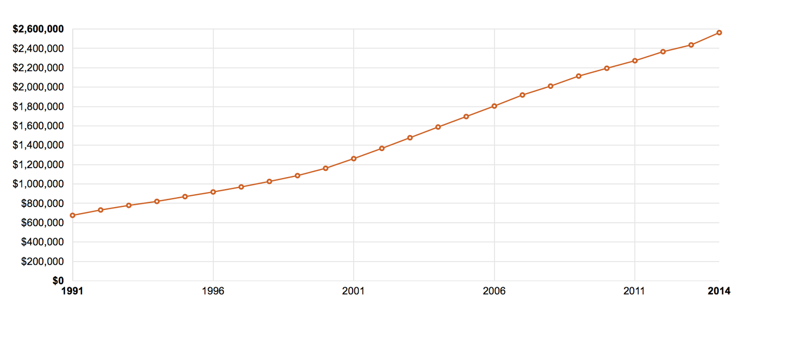

     Fig. Health Care Expenditures by State of Residence(CMS,2017)

Nowadays, the price of medical insurance in America goes higher quickly, which gives more and more people huge economic pressure. Under this kind of circumstance, UPMC is going to give a discount on medical insurance to those people who have more healthier life habits. And with implementing this new insurance plan, UPMC will attract more people with healthy life habits to choose UPMC. In addition to this, the plan of UPMC would stimulate more people to adopt a healthy lifestyle.

As we all know, the new insurance plan is fantastic. People who choose UPMC can have a more healthy lifestyle and save money on medical insurance. However, the most critical thing is how to measure or evaluate the behaviors of people who want to participate this plan. And UPMC has huge difficulties on how to create practical criteria to determine whether the lifestyle of one person is healthy and what is the healthy degree of their lifestyle.

Actually, it is a cliche to reduce the cost of healthcare for healthy people. But the most critical question is that we can not easily decide one person is healthy or not. And even if someone is healthy, we can not figure out how healthy this person is by giving some direct comparable values. In recent years, many insurance companies would like to provide this special discount healthcare service. They determined one people by submitting health forms, body mass index or even by their disease history. Although these companies take time and money to investigate the health conditions of one client, they always get inaccuracy data in the end.

By health forms filled by clients, companies can not get what happened actually because many people like to lie in this kind of forms. And by body mass index, there are always many people who are unhealthy but with a normal body mass index. So it is not feasible indeed. For disease history, it is not rational to decide clients’ present health condition by analyzing their disease history. All of these limitations should be solved by new advanced technology scientifically.

Under this kind of circumstance, our Smart UPMC insurance evaluate system would like to take responsibility to create a feasible and practical method to give a rational discount for healthcare. Our team will provide a lightweight low-power wearable camera for the client as a sensing device to get the diet and exercise information. And this device can capture the sensing pictures and upload them to cloud. These data would trigger the event and our function on cloud service can analyze these data to know the diet and exercise information.Then we can evaluate this info for each client so that we can decide if we would offer them a discount insurance policy. We choose the pictures when the clients are eating or exercising for about one month or longer. So we can evaluate the pictures by cloud computing function to detect the label quickly and automatically. And we can process pictures of very huge amount of people just by cloud service. What we need to do is to design the whole process carefully and make a perfect system for UPMC.